01.

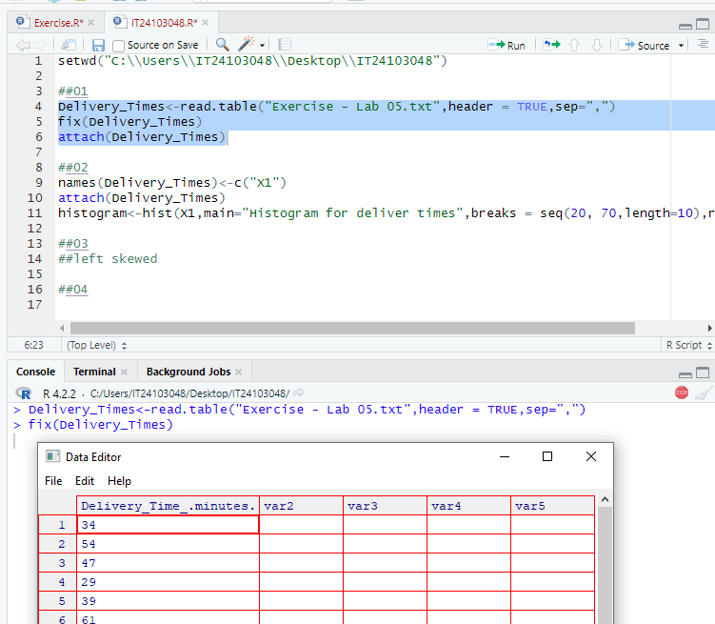

03. left skewed

04.

